Nordnes
Short: A charming waterfront neighborhood known for colorful wooden houses, quiet streets, and local character.
Long: Located on the northwestern peninsula of central Bergen, Nordnes is one of the city's oldest and most picturesque neighborhoods. Its narrow cobblestone streets, historic wooden homes, waterfront parks, and cafés offer a quieter alternative to the busy harbor. It's perfect for a leisurely morning walk and provides a glimpse into everyday life in Bergen. Many visitors consider it one of the city's most charming districts.
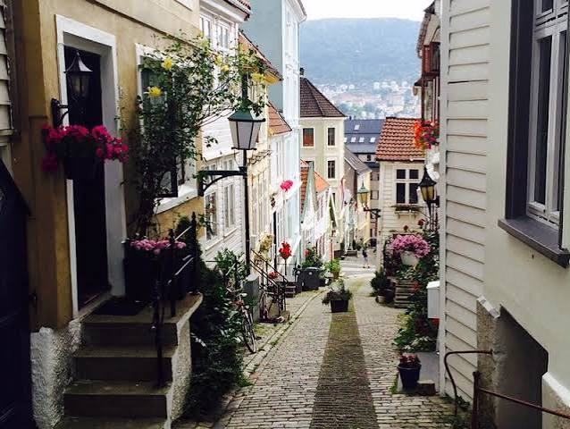
Bryggen
Short: Bergen's iconic UNESCO World Heritage waterfront lined with colorful Hanseatic merchant buildings.
Long: Located in the heart of Bergen's harbor, Bryggen has been the center of the city's maritime trade since the Middle Ages. Behind its famous colorful facades are narrow wooden alleyways filled with artisan shops, galleries, museums, and cafés. The historic wharf is one of Norway's most recognizable landmarks and offers a fascinating look into Bergen's Hanseatic past. It's an essential first stop for any visit to the city. Bryggen

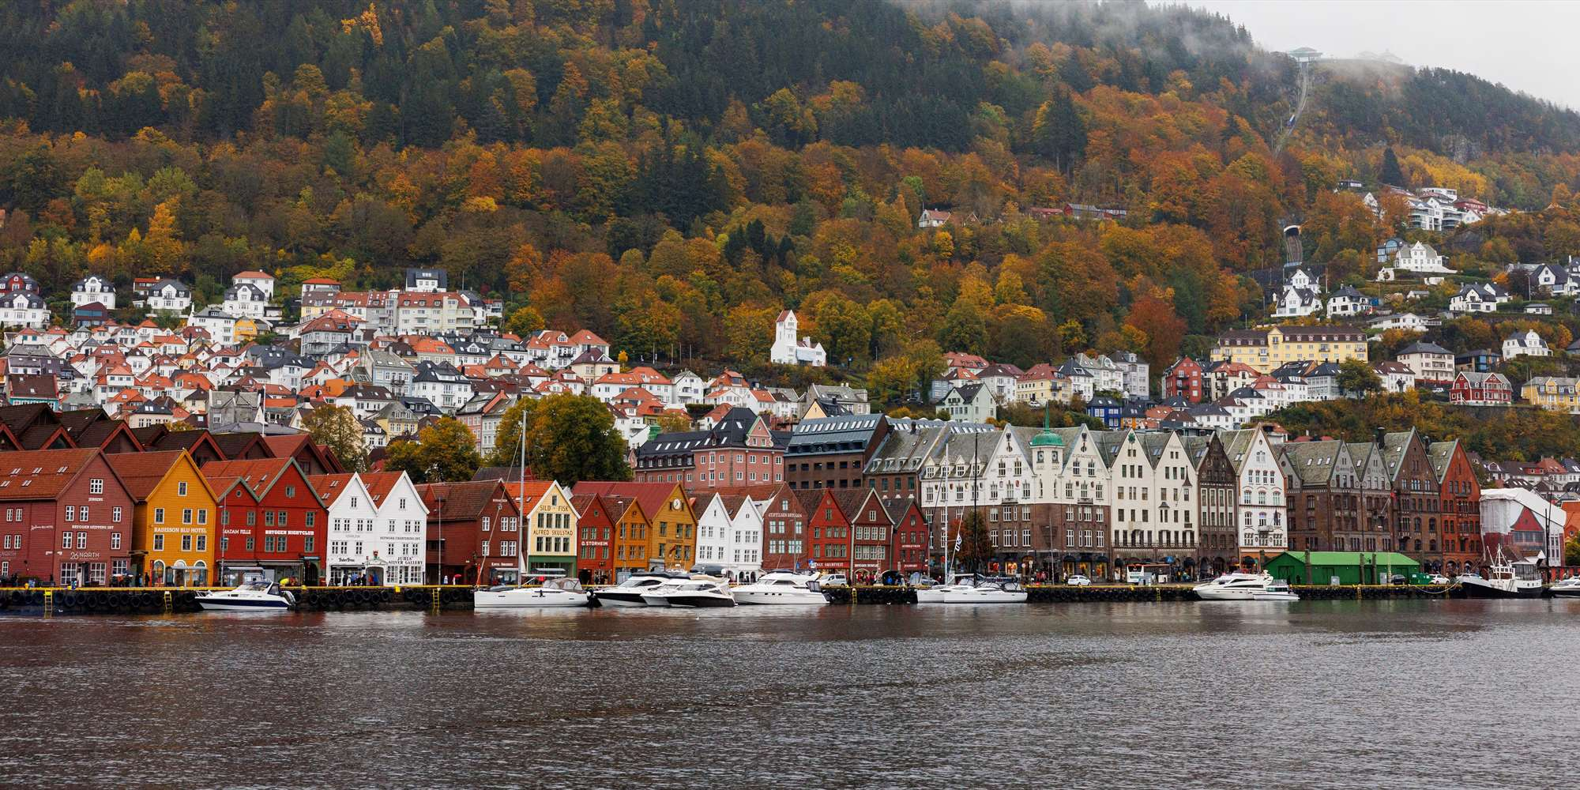
Kaf Kafe Bryggen
Short: A cozy café tucked inside Bryggen, perfect for coffee and homemade pastries.
Long: Located within Bryggen's historic wooden buildings, Kaf Kafe offers a relaxed atmosphere away from the busiest tourist streets. The café serves quality coffee, light lunches, and traditional Norwegian baked goods in a rustic setting that reflects the character of old Bergen. It's an excellent place to take a break while exploring the UNESCO-listed waterfront. The intimate atmosphere makes it feel like a hidden local favorite.
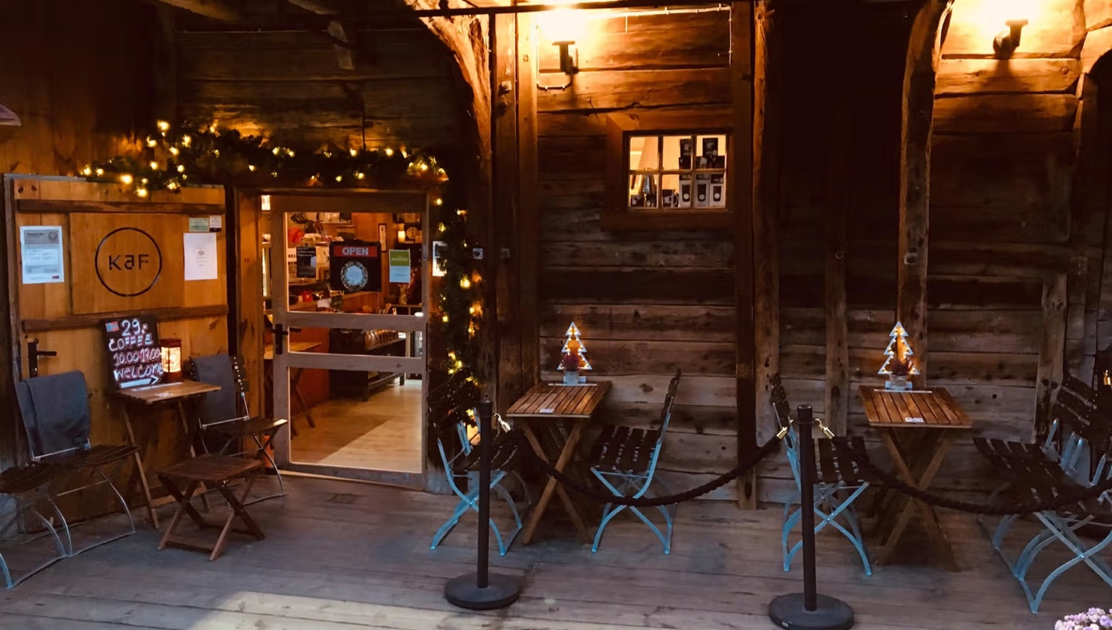

Skillingsboller Pastry
Short: Bergen's famous cinnamon bun, loaded with butter, cinnamon, and sugar.
Long: The skillingsbolle originated in Bergen over 500 years ago and remains the city's signature pastry. Larger and sweeter than a typical cinnamon roll, it's made with generous amounts of butter, cinnamon, and sugar, often with an extra layer sprinkled on top. Nearly every bakery in Bergen sells them fresh throughout the day, making them the perfect snack while sightseeing. Trying one is practically a Bergen tradition.

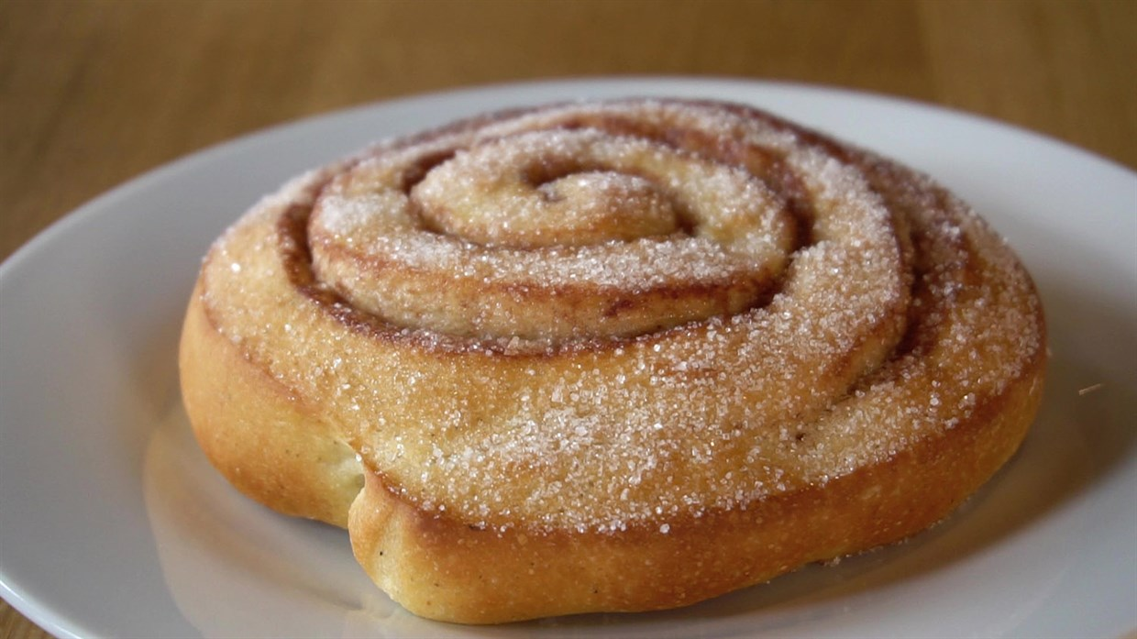
Mount Floyen
Short: Bergen's most famous viewpoint, offering panoramic views of the city, harbor, and surrounding fjords.
Long: Located just east of Bergen's city center, Mount Fløyen rises 320 meters (1,050 ft) above the harbor and is easily reached via the historic Fløibanen funicular or on foot. From the summit you'll enjoy sweeping views across Bergen, the surrounding islands, and nearby mountains. Numerous hiking trails begin here, ranging from easy walks to full-day adventures. It's one of the best places to appreciate Bergen's unique setting between mountains and sea.
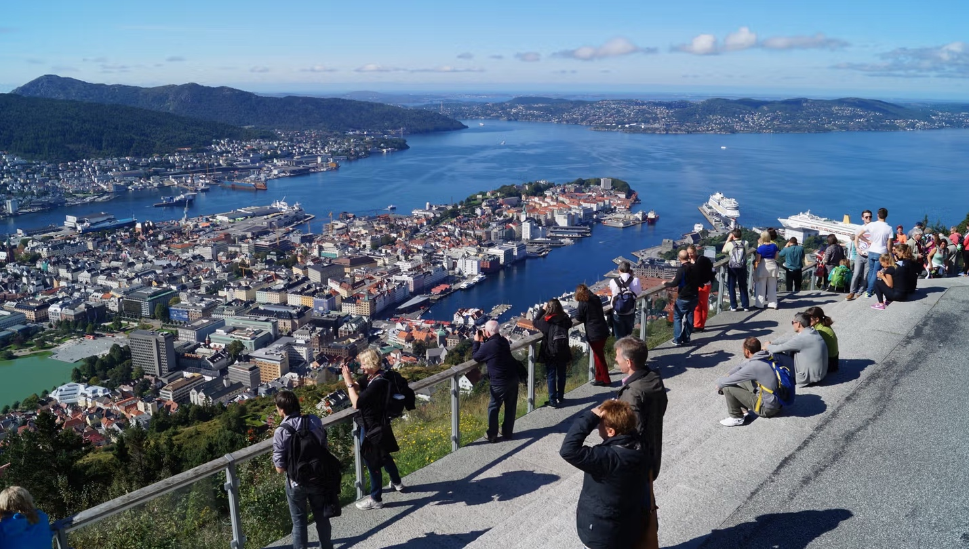
Nordness Pool
Short: A heated seawater pool and public bathing area overlooking the North Sea.
Long: Located at the tip of the Nordnes peninsula, Nordnes Pool is one of Bergen's favorite places to swim and relax. The facility features a heated outdoor seawater pool, diving platforms, saunas, and direct access to the fjord for those brave enough to take a cold plunge. During the summer it's popular with both locals and visitors looking to enjoy Bergen's waterfront. The setting provides beautiful views over the harbor and nearby islands.
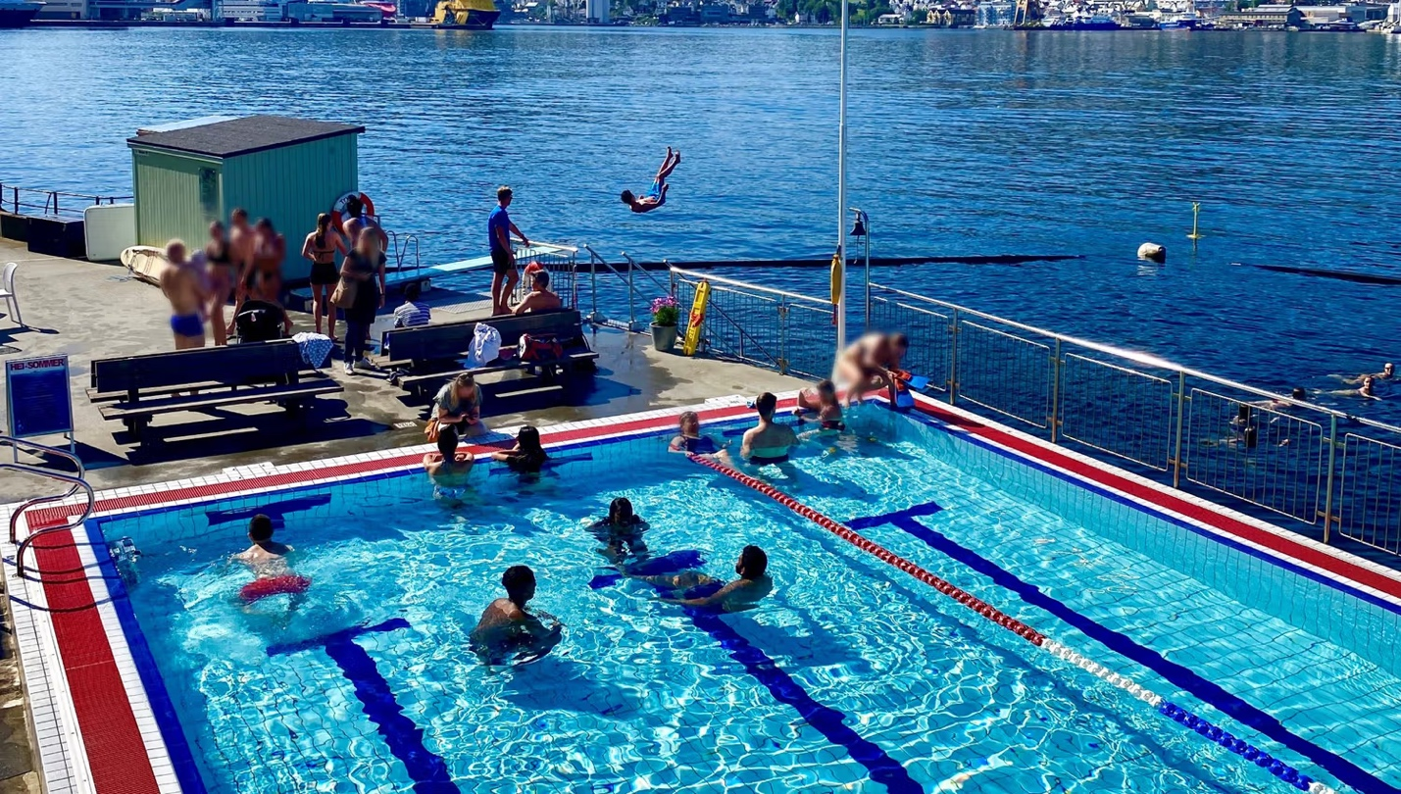
FjordExpedition AS, Bergen
Short: Guided kayaking tours that let you experience Bergen from the water.
Long: Located at FjordExpedition AS, Bergen near Bergen's historic harbor, this tour operator specializes in guided sea kayaking adventures. Tours paddle through the city's waterfront, historic wharves, and nearby fjords while guides share stories about Bergen's history and maritime culture. Both beginners and experienced kayakers are welcome, with all necessary equipment provided. It's one of the most memorable ways to experience Bergen from a completely different perspective.
